TopCoder API NodeJS Framework
Deployment Guide

Revision History
Author | Revision Number | Date
TCSASSEMBLER | 1.0 | 2013/10/23

Deployment Instructions 3
1. Organization of Submission 3
2. Application Setup 3
2.1. Preconditions 3
2.2. Build Script Setup 3
3. Configurations 4
4. Deployment Instructions 5
5. Verification 8
6. Source Verification 13
7. Resource Contact List 15

Deployment Instructions

Organization of Submission
The folder structure (the root directory of the submission is referred as the <base> throughout the document.
Name | Description
tcapi/ | Main application source code of this assembly.  It is in the actionHero app structure.
examples/ | The sample application that is used to get the OAuth 2 access token and test the API in a simple page.  It is an express.js application that hosts the web pages.
docs/ | The folder mainly

Application Setup

Preconditions
- Linux 64bit System (preferably the Ubuntu 10.04), which is used by Heroku stack for Nodejs), with development tool, such as g++, maker.
- Informix Client SDK (used to connect remote Informix Server)
- NodeJS 0.10.21 http://nodejs.org/
- NodeJS-DB-Informix https://github.com/amitkr/nodejs-db-informix
- Git
- Heroku Account and Toolbelt
  - Signup a Heroku account in https://api.heroku.com/signup/devcenter with your email address.
  - Download the Heroku Toolbelt from https://toolbelt.heroku.com, and make sure the Heroku CLI is working in your environment by typing the “heroku help”.

Build Script Setup
Two BASH scripts are used to ease the deployment.
- deploy/development.sh
It helps to launch the application locally.
It simply exports the configured environment variables and then launch the Node.js application.
- deploy/heroku.sh
It helps to deploy the application onto the Heroku cloud.
It has command line switches.
Switch | Description
clean | It cleans the current repository information by simply removing the .git folder.
commit | It initializes the local repository and commits all the current project files, if the current directory is not a GIT repo yet; or commit all the changes to the local repository, if the current directory is already a GIT repo.
create | It creates a Heroku app for the current logged-in Heroku account.  This app will only be used if it is created when the current local GIT repo has not yet setup the remote repo of name “heroku”.  If your local repo has already setup “heroku” remote for an existing app, this app will not be picked as the target app for other Heroku commands. If you want to create an new Heroku app and use it as the target app in this case, you can clean and re-initialize the current local repo first, or you explicitly rebase it to the new Heroku app.
config | It exports all the configured environment variables to the target Heroku app.
push | It pushes the current committed version to the “heroku” remote.
launch | It launches one Heroku dyno to run the target app.
all | It will execute all other steps in the order: “clean”, “commit”, “create”, “config”, “push”, and then “launch”.
deploy | It only executes the steps to deploy the projects to the Heroku cloud: “config”, “push”, and then “launch”.  It assumes the code has been committed to the local repo, and the local repo has setup the “heroku” remote for the target app.

Configurations
There are two BASH scripts used to ease the deployments and launching of the application.
The configurations are defined in these scripts to export the environment variables.
One of them is for local development “tcapi/deploy/development.sh”, where configurations are defined from 3 – line 7, like:
export TC_DB_HOST=50.17.156.219
export TC_DB_PORT=2021
export TC_DB_USER=informix
export TC_DB_PASSWORD=1nf0rm1x
export TC_API_HOST=api.topcoder.com
The other is for deploying the application to Heroku, where the configuration are defined in line 58 – 62, like
heroku config:set TC_DB_HOST=50.17.156.219 \
TC_DB_PORT=2021 \
TC_DB_USER=informix \
TC_DB_PASSWORD=1nf0rm1x \
TC_API_HOST=api.topcoder.com

Deployment Instructions
For the local deployment, you only need to run the “. deploy/development.sh” from within the “tcapi” directory.
This section mainly describes the steps to deploy the application to Heroku. Tutorial for running Node.js application in Heroku can be found here.
The following steps use a BASH script to ease the deployment (see 2.2).
The instructions assume you have installed the Git software, where the command “git” is working.
The instructions assume that you are in Debian/Ubuntu OS (which is used by the Heroku).
The instructions assume that you have Heroku account and have installed the Heroku Toolbelt.

  - Prepare the dependencies
The submission contains all the source code files, without the dependencies (node modules). The IBM library should be downloaded from here, since it is too large. The “thirdparty” directory should be copy to the “tcapi” directory, so that the path to the target directory is “<base>/tcapi/thirdparty/”.
The “nodejs-db-informix” cannot be rebuilt with Node v10, thus you should download the built version from here.
You will then need to go to the “<base>/tcapi” and run the “npm install” to install the other dependencies.

  - Go to the application directory “<base>/tcapi/”.

  - Login your Heroku account by typing the “heroku login”.
This requires you to input your email and password, and then finally it will upload your public SSH key to the server so that you don’t have to provide your credential during the subsequent commands.

  - Run the “. deploy/heroku.sh all” from the directory “<base>/tcapi/”
The script does the following things:
- Initialize the local Git repository, with “git init”
- Commit the files to the local Git repository, with “git add” and “git commit”
- Create an app on the Heroku for testing (this is supposed be used in the first time only), with the “heroku create”
- Set the environment variables to the Heroku app, with the “heroku config:set”.
- Push the application files to the remote repository, with the “git push heroku master”. In the meantime it will be deployed to the Heroku.
If this step yields a “Permission denied (publickey)” error, you can use “heroku keys:add” to add the public key to the remote repo as described here.
- Launch the Heroku Dyno for the app, with the “heroku ps:scale web=1”.
The use of those steps is described in the tutorial.
For the first time to deploy the application, you will only need to run the script with “all” option, from within the application directory (the “tcapi” directory” in our case).
There is the sample screenshot of the output of the script: (the git commit part is ignored since the output of it are too long)
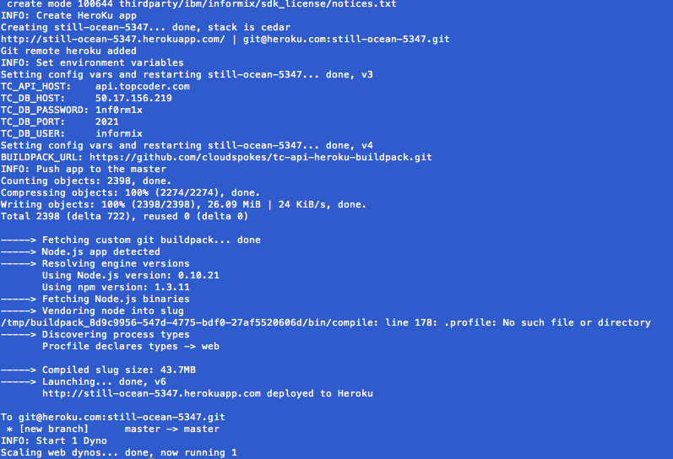
The screenshot shows the output starting from the step where the Heroku app is created.
After running the script, you can use “git remote –v” to see the “heroku” remote repo. The remote repo will be like git@heroku.com:<app-name>.git, you can know the create app name here.

  - Then you can run the “heroku logs” to see the server log.
It will be like this:
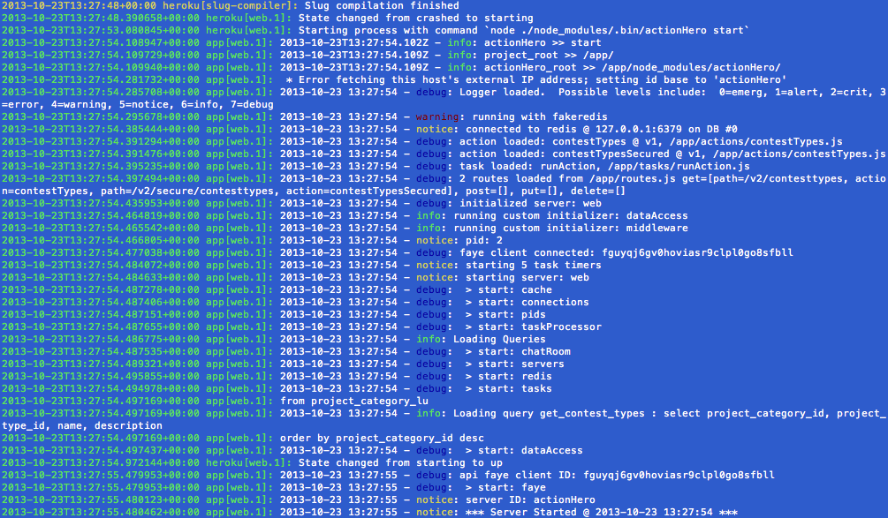

  - You can access to the unprotected “Get Contest Types” API in our browser for quick verification.
The URL will be the http://<your-app>.herokuapp.com/api/v2/contesttypes. It is like:
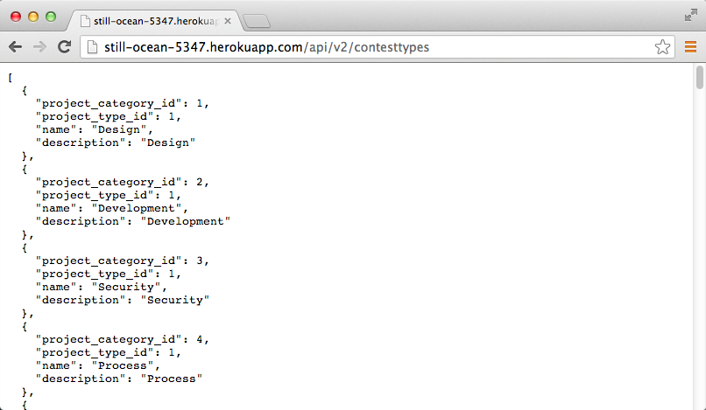

Verification
The example application (contained in the <base>/examples directory) can be used to verify the installed application, especially for the API that protected by OAuth 2.
The following instructions are for verifying the app running at Heroku cloud. For the case when the app is running locally, you can simply use the “localhost:8080” as the endpoint.

  - Set up the example application
Run “npm install” from within the “<base>/examples” directory.

  - Configure the example application
The example application is configured in the <base>/examples/config.js file. It mainly contains the OAuth related configurations to get the access token.
clientID: "0af315c5",
clientSecret: "766a21fe4c8e6d2e332983471ace9902",
callbackURL: "http://<your-host-or-ip>:3000/topcoderoauth/callback",
apiHost: "api.topcoder.com",
scope: ["FORUMS_REST", "CONTEST_REST"]
You can get your own client ID and client secret from the https://dev.topcoder.com/ but the given ones should be working well.
The API host “api.topcoder.com” is the production one, which can be used for testing since the OAuth processing doesn’t change business data.
The permission “CONTEST_REST” is required for testing our API.

  - Run the example application
Typing the “node app.js” from within the “<base>/examples” directory can launch the application.

  - Goes to the “http://<your-host-or-ip>:3000/client” you will see the following page:
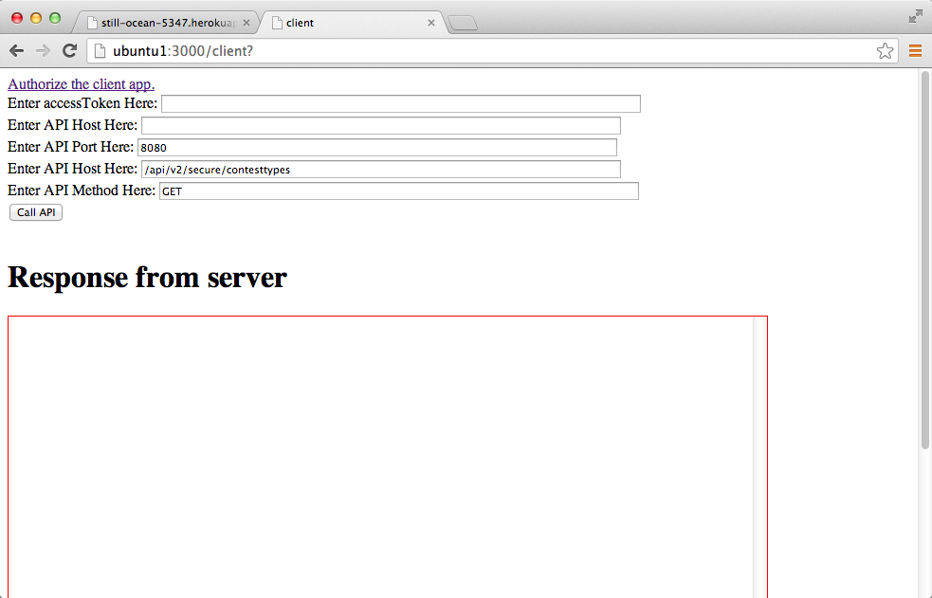

  - Get the OAuth access token by clicking the “Authorize the client app” link.
You will be redirected to here:
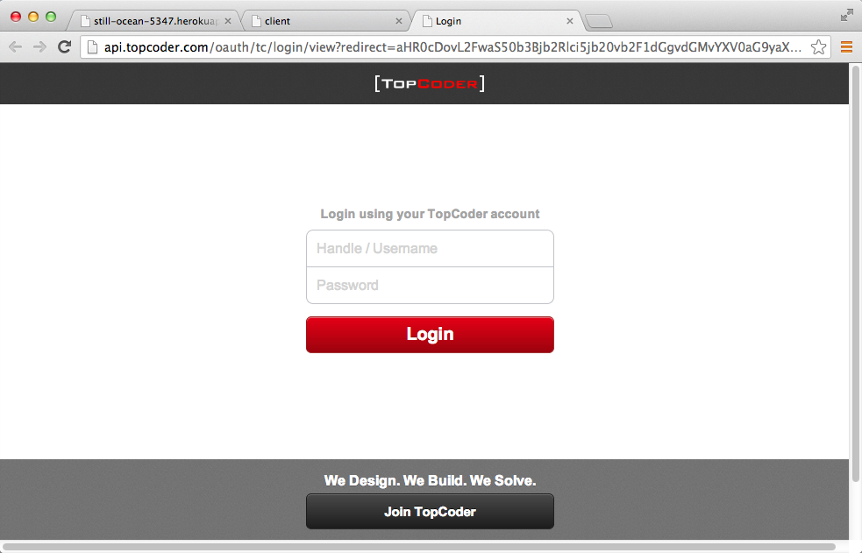
  - Login and Authorize the App
Login with your real TC handle/password, and authorize the client app by clicking the “Allow” button:
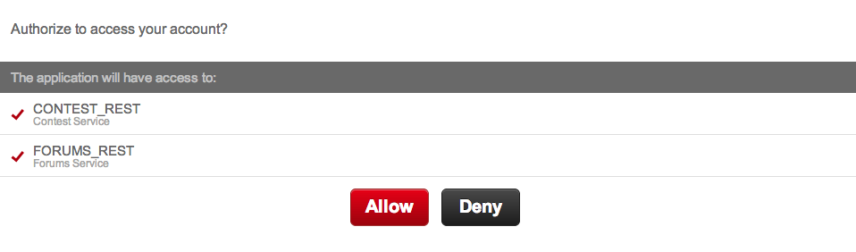

  - You will be redirected back to the example app page that shows the Access Token:
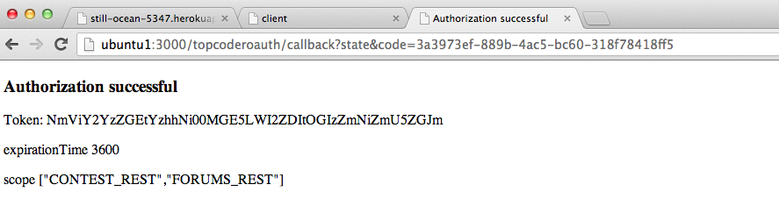
  - Enter the parameters and test the secured API
You then go back to the “client” page and fill the necessary parameters, like this (assuming we test the API hosting in the http://still-ocean-5347.herokuapp.com/, which you should replace it with your own Heroku app):
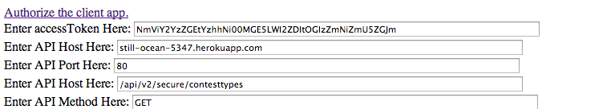
After you fill the parameters, and click on the “Call API”, the response will be obtained like this:
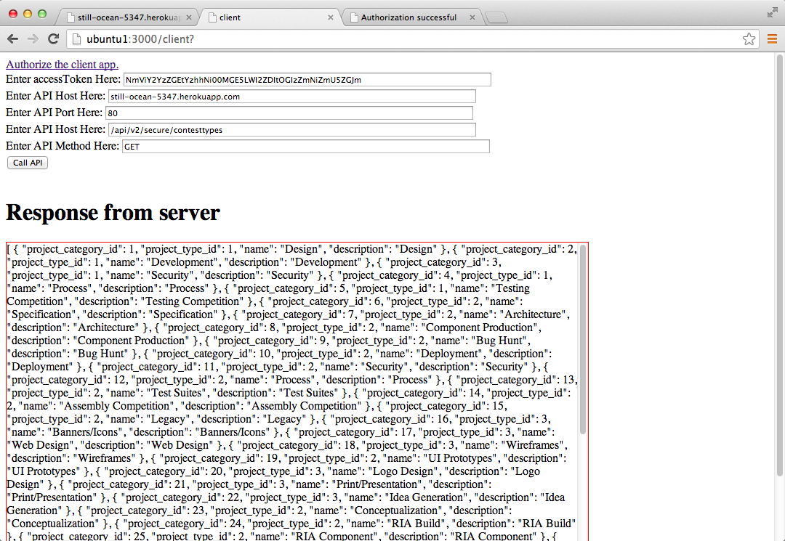

  - Alternatively, you can use the Chrome plugin Postman to test different cases, where the access token is used or not, to see the different responses.
When you access the correct access token in the Authorization Header, you will get:
(The Authorization header is “Bearer <your-access-token>”
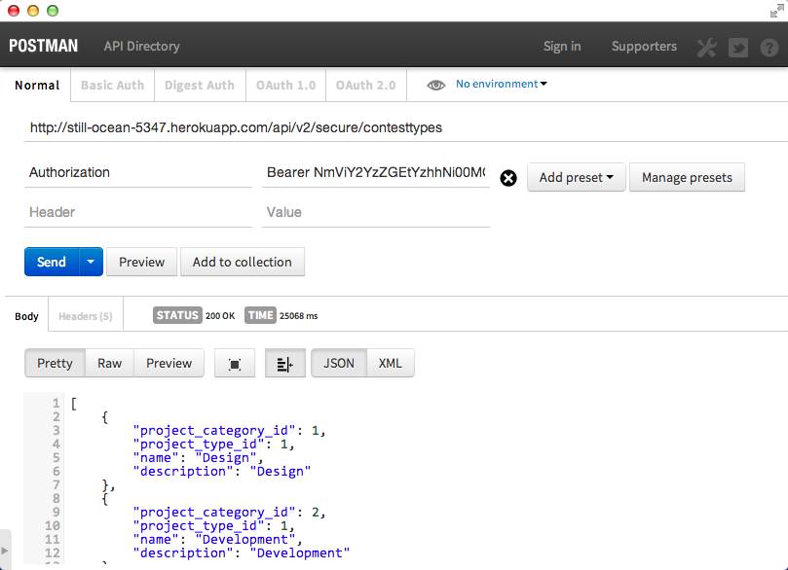

If you didn’t provide the access token, you will get:
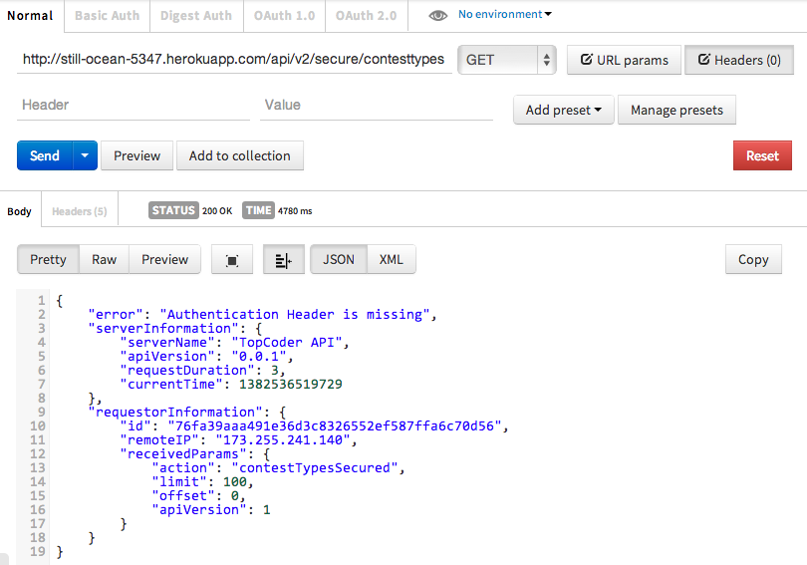

If you provide a wrong access token, you will get:
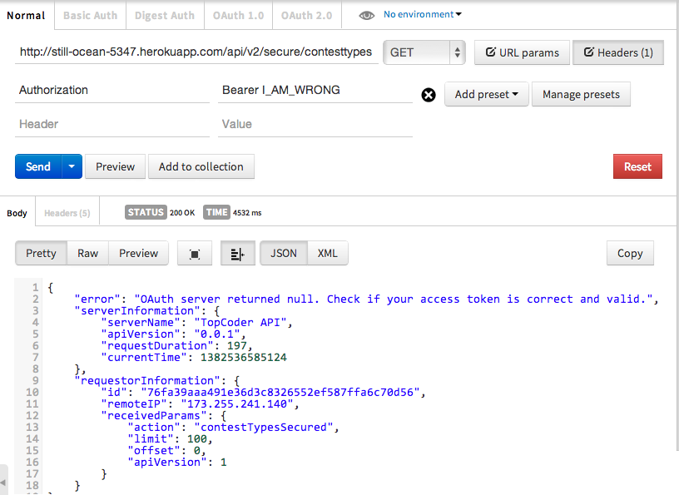

Source Verification
Since the contest require the source code to be restructured, here is the list for you to verify whether the requirements are met:

  - Change the overall architecture to use the actionhero.js framework
The application under the “<base>/tcapi” directory is now exactly based on the actionHero.js.

  - Switch the config files to environment variables; provide initial support/documentation for dev (local), staging (Heroku), and production environments; and provide two bash scripts to set the dev / heroku configuration values to environment variables.
All configurations (that are variables to different environments) are switched to the environment variables. See the section 3 “Configurations”.
Two scripts are provided to set the environment variables. See the section 3 and section 4.
Regarding the differences of staging or production environment, we only need to properly create and/or use different “Heroku app”, set the different environment variable values in the “heroku.sh” script, and run the “. deploy/heroku.sh config” to propagate the variables to the remote Heroku app.
For the “.profile” file, since it is simply used to set the list of “Informix related” environment variables, which can be considered the same in all different Heroku “environments”, we don’t have to externalize the steps out.

  - Use actionHero preprocessing for oauth.
It is done in the <base>/tcapi/initializers/middleware.js, where a preprocessor is added for authorization. It checks the Authorization header by sending request to the OAuth provider URL.
For the action that needs to be protected by OAuth, we need to set the “permissionScope” in the action configuration like:
exports.contestTypesSecured = {
name : 'contestTypesSecured',
description : 'contestTypesSecured',
inputs : {
required : [],
optional : []
},
permissionScope : 'CONTEST_REST',
....
}
Any action that has the permission scope will be protected with OAuth.

  - Move existing contest types API implementation into actionHero action and setup correct action hero routes.
The API is defined in the <base>/tcapi/actions/contestTypes.js and the routes are defined in the <base>tcapi/routes.js.

  - Create another actionHero action for contest types API and require OAuth authentication in the route.
Same as above

  - Use the Winston logger of actionHero. Add loggers at API group level instead of different loggers at controller level.
The Winston logger of actionHero is now being used (api.log()).
For the multiple loggers, see here.

  - Make all code pass jslint with nomen=true and use simple commenting instead of java style comments.
Install the node-jslint in your local environment globally by “sudo npm install jslint -g".
Check the following files (which contain the application code) under the <base>/tcapi
jslint --nomen actions/contestTypes.js
jslint --nomen initializers/dataAccess.js
jslint --nomen initializers/middleware.js
jslint --nomen routes.js
jslint --nomen config.js
The “tests” and the “examples” are not application code so I believe they don’t have to pass the JSLint rules.
The comments are changed to use the style applied in the code of projects like “express.js”.

  - Move the OAuth demos into it's own completely separate /examples directory.
It is now in the <base>/examples, and it does not contain any API implementation.

  - Remove crud.html and stored procedures. We don't want to use stored procedures in this project.
Removed

  - Use json files to store the SQL instead of hard code it in source file. Note that node require can load JSON files with no problem (don't use fs.readFile or fs.readFileSync).
Loading SQL from text files in the “<base>/tcapi/queries/” is implemented in the “<base>/tcapi/initializers/dataAccess.js”.
The approach is accepted here.

  - Create a test directory. Add tests for the get contest types API. Use supertest with mocha. Don't install mocha globally.
Separate directory “<base>/tcapi/test/” is created. And a separate test file that uses supertest with mocha is provided as the “<base>/tcapi/test/get_contesttypes.js”
To run the test, you need to set your target API endpoints (like http://still-ocean-5347.herokuapp.com/ ) in the get_contesttypes.js.
Then you run the “./node_modules/.bin/mocha” from within the “<base>/tcapi/” directory.

  - Remove the custom heroku buildpack. It's not needed after you complete #2..
It was discussed here.
We cannot remove the custom buildpack by using the “heroku config:set”.

Resource Contact List
Name | Resource Email

